**MAT1011 – Calculus for Engineers (MATLAB), Fall Semester 2020-2021**

**Digital Assignment SL. 5, Experiment – 3A: Plotting of 3D Curves and Taylor Series**

**By: Jonathan Rufus Samuel (20BCT0332) Date: 3.12.2020**

__________________________________________________________________________________

**Q1) Write a program for a 3D parametric Curve x = cos 2t, y = sin 3t, z = sin 5t using plot 3 command:**

A: Code is as follows:

%Write a program for a 3D parametric Curve

% x = cos 2t, y = sin 3t, z = sin 5t using plot 3 command:

clear

clc

t = linspace(0,2*pi,500);

x = cos(2*t);

y = sin(3*t);

z = sin(5*t);

plot3(x,y,z);

xlabel('x-axis');

ylabel('y-axis');

zlabel('z-axis');

Output (via Command Window): -

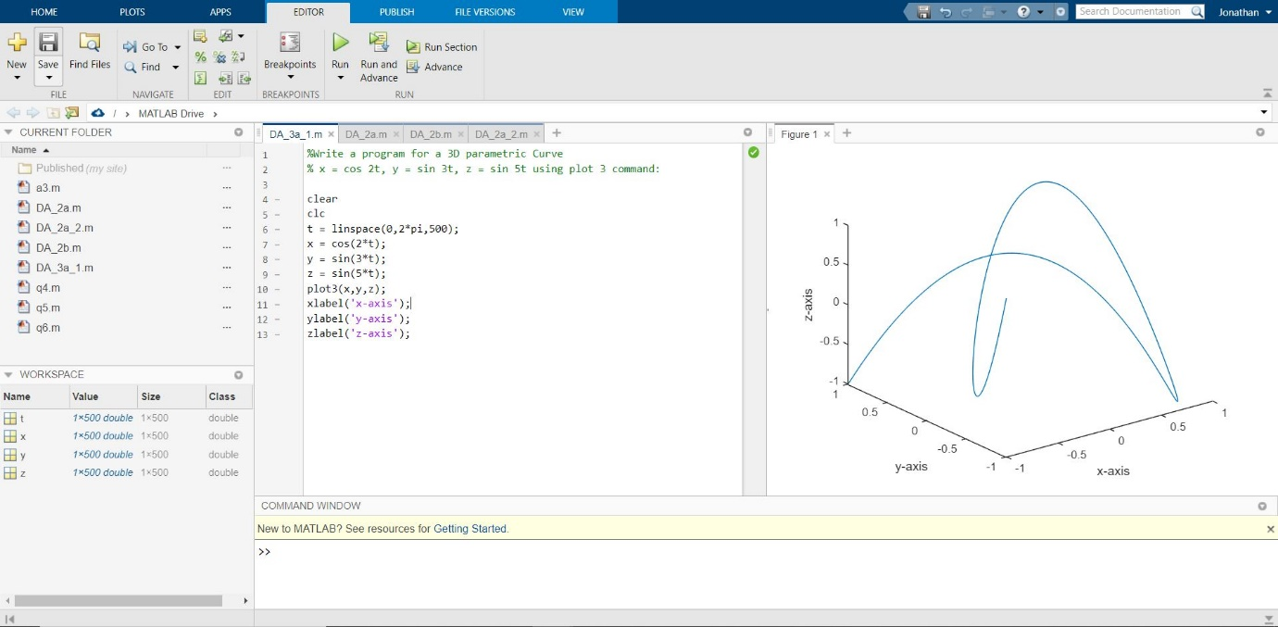

**Q2) Write a MATLAB code for the parametric equations x = cos 2t, y = sin 2t, z = 2t using ezplot command.**

A: Code is as follows:

%Write a MATLAB code for the parametric equations x = cos 2t,

% y = sin 2t, z = 2t using ezplot command.

clear

clc

syms t

x = cos(2*t);

y = sin(2*t);

z = 2*t;

ezplot3(x,y,z,[0,6*pi]);

xlabel('x-axis');

ylabel('y-axis');

zlabel('z-axis');

Output (via Command Window): -

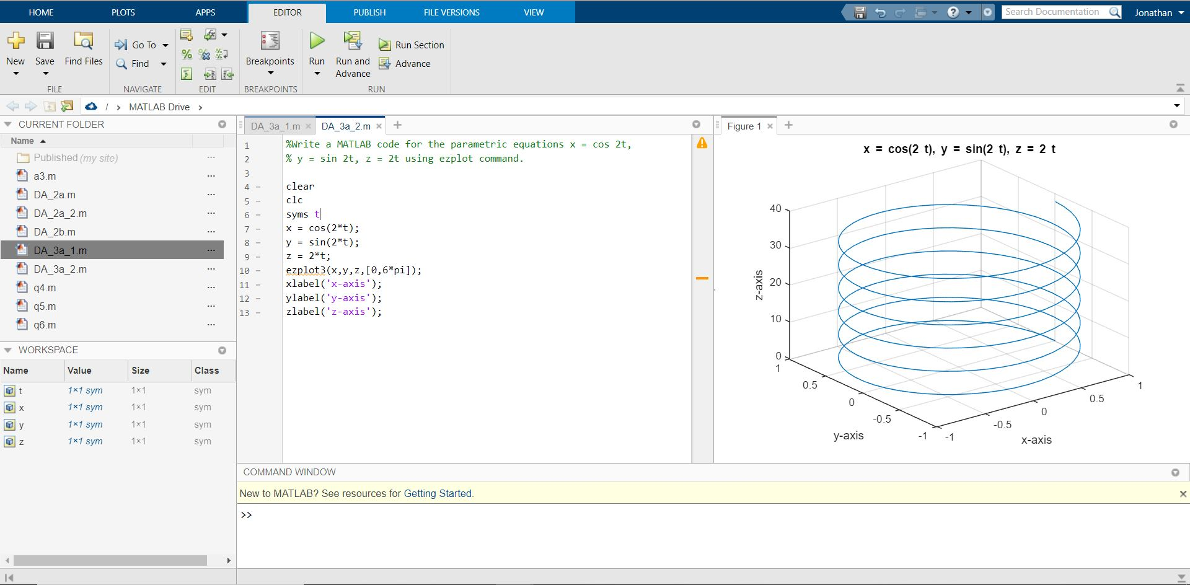

**Q3) Write a MATLAB code for the function f(x,y) = 2(x^2 + y^2) using ezsurf command.**

A: Code is as follows:

%Write a MATLAB code for the function f(x,y) = 2(x^2 + y^2)

% using ezsurf command.

clear all

clc

syms x y

f = 2 * (x^2 + y^2);

ezsurf(f);

colormap winter;

Output (via Command Window): -

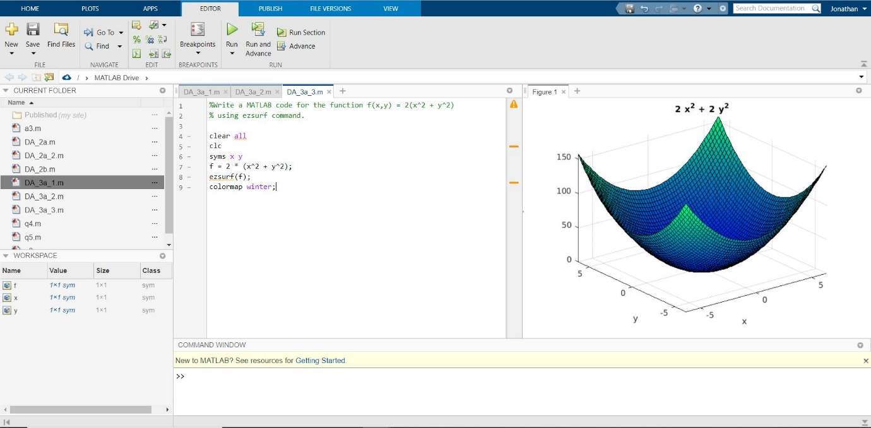

**Q4) Write a MATLAB code for Taylor’s series of the function f(x,y) = e^x.siny evaluated about the origin.**

A: Code is as follows:

%Write a MATLAB code for Taylor*s series of the function f(x,y) = e^x*siny

% evaluated about the origin.

clear all

clc

close all

syms x y

f = exp(x)*sin(y);

I = [0,0];

a = I(1);

b = I(2);

z = taylor(f, [x,y], [a,b]);

subplot(1,2,1);

ezsurf(f);

subplot(1,2,2);

ezsurf(z);

Output (via Command Window): -



